**2025 Rev. Dr. Martin Luther King Essay Contest**

**Sponsored by the Wooster-Orrville NAACP**

**Grade Categories:**

**1) *Students in grades 1st through 3rd* will write essays with a minimum of 150 words/maximum 500 words.**

2) ***Students in grades 4th through 6th* will write an essay with a minimum of 500 words/maximum 800 words.**

3) ***Students in grades 7th through 9th***  **will write essays with a minimum of 700 words/maximum of 1000 words.**

4) ***Students in grades 10th through* 12th will write essays with a minimum of 900 words/maximum 1200 word*s.***

**Essay Format:**

**Required**: Each essay submitted is required to have a **Title** and all of the following information in the ***upper right hand corner of Page 1*:**

**Student’s First and Last Name/ Teacher’s Name/ Grade Level and School.**

We also encourage teachers to have students write an i*ntroduction* and *conclusion* along with the main body of the essay.

**Awards:**

**In each Category**, 1st, 2nd, and 3rd place winners will receive the following awards:

1st place: $175.00

2nd place: $150.00

3rd place: $125.00

**Due date for Essays: Friday, *December 6, 2024, 5pm.***

**\*Essays in the following school districts will be turned in as follows: Wooster SD teachers turn in essays to Wooster City Schools Board of Education Office; Orrville/Rittman SD teachers turn in essays to the Superintendent’s office. *Essays from individual students and other school districts will be turned in to Trinity UCC Church office, 150 E. North St., Wooster (Rev Kevan Franklin, 330-264-9250) by 5pm December 6.***

**\*The Rev. Dr. Martin Luther King Day Celebration Service will be Monday, January 20, 2025, 7pm, at First Presbyterian Church in Wooster. The Essay Contest Award winners will be presented during that Service. We will provide updates well in advance of the Dr. King Day event.**

**\*Upon submission all essays become the property of the NAACP. All winners’ essays are kept on file indefinitely. Students are encouraged to make copies of their essays before submitting them on December 6th.**

***\*Questions? Contact Mady Noble, 330-465-4080.***

**2025 Dr. Martin Luther King Essay Contest: Grades 1-3**

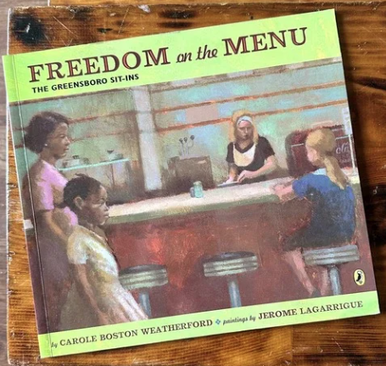

It is February 1, 1960 in Greensboro, North Carolina. Four black college students will break the law that day by sitting down at a “whites only” lunch counter in a Woolworth’s Five and Dime Store. The story, *Freedom on the Menu* by Carole Weatherford, imagines a black family in Greensboro who supports the Sit Ins to challenge this unfair segregation law.

**Essay Prompt**

Read the book, *Freedom on the Menu*, or show the book video [link below] after giving students the context for the story. Have students write an essay on Connie’s experiences as she watches her brother and sister and her parents get involved in the Sit-Ins, *using the following as a guide*:

*Because Connie was black, what are some things she could not do in her hometown in 1960? If you were a black child at that time in Greensboro, what would have upset you the most?

*When Connie’s sister and brother joined the sit-in and marching downtown, how did she help them? Would you have been afraid for your brother or sister in that situation?

*What are the parts in this book that you liked or that got your attention? What did you like most about Connie?

[Children are invited to create a sign that Connie might have made for her sister as she marched at the Woolworth store [maximum 8 x11].

**Suggested Resources**

Book: Carole Weatherford, *Freedom on the Menu [The Greensboro Sit-Ins*], Puffin Books, 2005. Widely available.

<https://www.youtube.com/watch?v=SO3PjLpMZFU> [copy and paste into browser

Monrovia Public Library video *Freedom on the Menu* [forward to 1:50]

<https://amhistory.si.edu/ourstory/pdf/freedom/lunchcounter_reading.pdf>

Teacher guide and background for *Freedom on the Menu*.

Thank you for participating in the 2025 Dr. Martin Luther King Essay Contest.

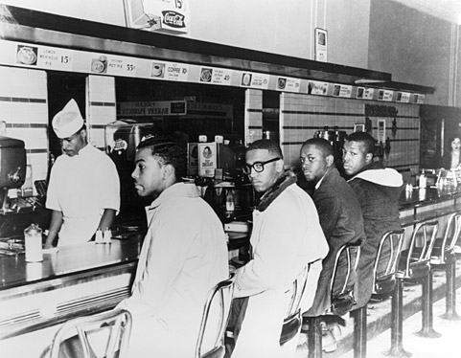

On February 1, 1960 in Greensboro, North Carolina, these 4 black college students break the law by sitting at a “whites only” lunch counter in a Woolworth’s Five and Dime Store. The photo above shows the first “Sit In” by the Greensboro students waiting to be served and being ignored.