**2025 Rev. Dr. Martin Luther King Essay Contest**

**Sponsored by the Wooster-Orrville NAACP**

**Grade Categories:**

**1) *Students in grades 1st through 3rd* will write essays with a minimum of 150 words/maximum 500 words.**

2) ***Students in grades 4th through 6th* will write an essay with a minimum of 500 words/maximum 800 words.**

3) ***Students in grades 7th through 9th***  **will write essays with a minimum of 700 words/maximum of 1000 words.**

4) ***Students in grades 10th through* 12th will write essays with a minimum of 900 words/maximum 1200 word*s.***

**Essay Format:**

**Required**: Each essay submitted is required to have a **Title** and all of the following information in the ***upper right hand corner of Page 1*:**

**Student’s First and Last Name/ Teacher’s Name/ Grade Level and School.**

We also encourage teachers to have students write an i*ntroduction* and *conclusion* along with the main body of the essay.

**Awards:**

**In each Category**, 1st, 2nd, and 3rd place winners will receive the following awards:

1st place: $175.00

2nd place: $150.00

3rd place: $125.00

**Due date for Essays: Friday, *December 6, 2024, 5pm.***

**\*Essays in the following school districts will be turned in as follows: Wooster SD teachers turn in essays to Wooster City Schools Board of Education Office; Orrville/Rittman SD teachers turn in essays to the Superintendent’s office. *Essays from individual students and other school districts will be turned in to Trinity UCC Church office, 150 E. North St., Wooster (Rev Kevan Franklin, 330-264-9250) by 5pm December 6.***

**\*The Rev. Dr. Martin Luther King Day Celebration Service will be Monday, January 20, 2025, 7pm, at First Presbyterian Church in Wooster. The Essay Contest Award winners will be presented during that Service. We will provide updates well in advance of the Dr. King Day event.**

**\*Upon submission all essays become the property of the NAACP. All winners’ essays are kept on file indefinitely. Students are encouraged to make copies of their essays before submitting them on December 6th.**

***\*Questions? Contact Mady Noble, 330-465-4080.***

**2025 Dr. Martin Luther King Essay Contest: Grades 10-12**

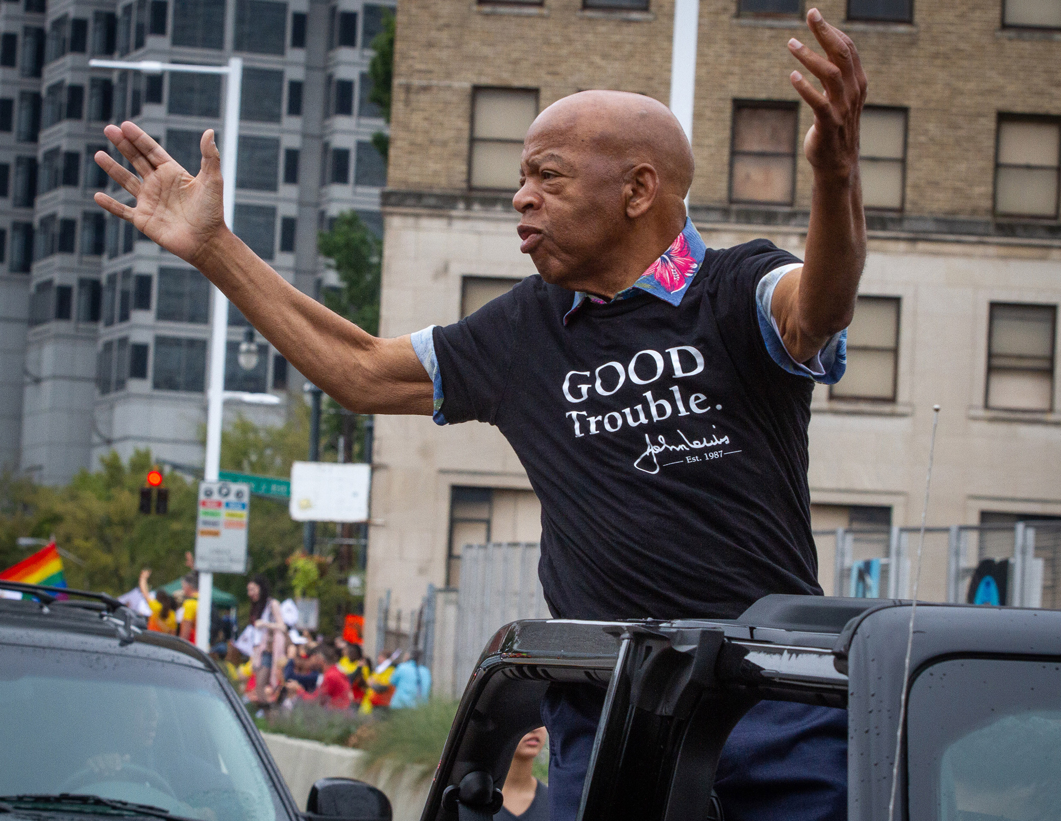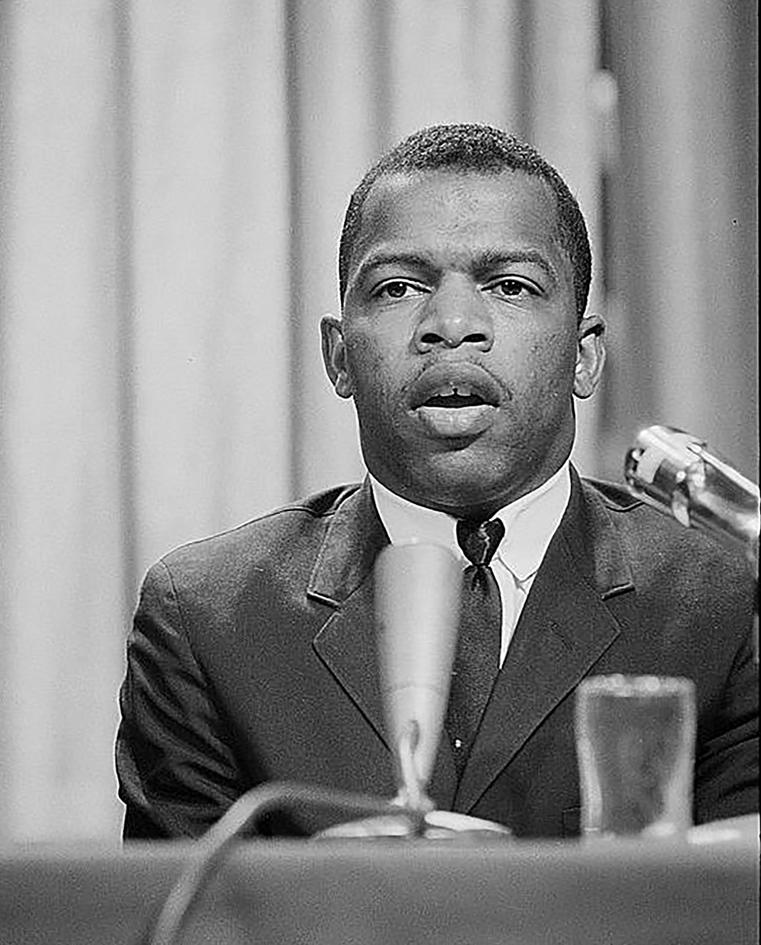

**John Robert Lewis** died July 17, 2020, at age 80, less than 2 months after the death of George Floyd on the streets of Minneapolis. A major figure in the Civil Rights Movement, inspired by the nonviolent philosophy of Dr. Martin Luther King, Jr., Lewis was first elected to the U.S. House of Representatives from Georgia in 1986 and served 17 consecutive terms. A civil rights activist throughout his life, he wrote a message right before he died addressed to all Americans to continue the nonviolent struggle to ensure equal rights and justice for all people.

**Essay Prompt**

Read John Lewis’s message to the nation, *Together, You Can Redeem the Soul of Our Nation,* written before his death in 2020. Write an essay based on Lewis’s words in this essay:

-how they reflect about his own life experiences as a young activist in the Civil Rights Movement;

-how they might be related to events and issues in the United Sates today;

-and how you personally relate, or react, to his call for your generation to “make good trouble.”

**Link** to Lewis’s last message [copy and paste into browser]

<https://www.nytimes.com/2020/07/30/opinion/john-lewis-civil-rights-america.html>

**Lewis obituary** in *Atlanta Journal-Constitution* for **background on his life**:

<https://www.ajc.com/john-lewis-obituary/>

**Lewis** meets a man who attacked him in 1961, Oprah program on Freedom Riders

[forward to minute 18 to 24]

<https://www.google.com/search?q=Elwin+Wilson+and+john+Lewis+youtube&rlz=1C5CHFA_enUS523US523&oq=Elwin+Wilson+and+john+Lewis+youtube&aqs=chrome..69i57j33i160l4.34097j0j4&sourceid=chrome&ie=UTF-8#fpstate=ive&vld=cid:b67ec060,vid:gBfuzj43ku4,st:0>

Students are encouraged to find their own resources on John Lewis.