**2024 Rev. Dr. Martin Luther King Essay Contest**

**Sponsored by the Wooster-Orrville NAACP**

**Grade Categories:**

**1) *Students in grades 1st through 3rd* will be required to write an essay with a minimum of 150 words/maximum 400 words.**

2) ***Students in grades 4th through 6th* will be required to write an essay with a minimum of 400 words/maximum 700 words.**

3) ***Students in grades 7th through 9th***  **will be required to write essays with a minimum of 600 words/maximum of 900 words.**

4) ***Students in grades 10th through* 12th will be required to write essays**

**with a minimum of 900 words/maximum 1200 word*s.***

**Essay Format:**

**Required**: Each essay submitted must have a **Title** and all of the following information in the ***upper right hand corner of Page 1*:**

**Student’s First and Last Name/ Teacher’s Name/ Grade Level and School.**

We are also encouraging teachers to have students write an i*ntroduction* and *conclusion* along with the main body of the essay.

**Awards:**

**In each Category**, 1st, 2nd, and 3rd place winners will receive the following awards:

1st place: $175.00

2nd place: $150.00

3rd place: $125.00

**Due date for Essays: Friday, *December 8, 2023, 5pm.***

**\*Essays in the following school districts will be turned in as follows: Wooster SD teachers turn in essays to Wooster City Schools Board of Education Office (Diane Lepley); Orrville/Rittman SD teachers turn in essays to Superintendent Jon Ritchie’s office. *Essays from individuals and other school districts will be turned in to Trinity UCC Church office, 150 E. North St., Wooster (Rev Kevan Franklin, 330-264-9250) by 5pm December 8.***

**\*The Rev. Dr. Martin Luther King Day Celebration Service will be Monday, January 15, 2024, 7pm, at First Presbyterian Church in Wooster. The Essay Contest Award winners will be presented during that Service. We will provide updates well in advance of the Dr. King Day event.**

**\*Upon submission all essays become the property of the NAACP. All winners’ essays are kept on file indefinitely. Students are encouraged to make copies of their essays before submitting them on December 8th.**

***\*Questions? Contact Mady Noble, 330-465-4080.***

**Grades 4-6 Prompt**: Seventy years ago it was legal in the United States to force black children and teens to attend all black public schools separate from the white schools. The ‘separate but equal’ policy had been in effect since 1896 and applied also to parks, libraries, restrooms, buses, and many stores and restaurants. In 1954 the U.S. Supreme Court ruled in *Brown v. Board of Education* that state laws legally separating black and white schoolchildren were wrong and must change. Three years earlier in Topeka, Kansas, nine year old Linda Brown’s family and the NAACP had gone to court to argue against the School Board policy that denied Linda the right to attend a white school closer to her home.

(1) What did Linda Brown have to do everyday to get to Monroe School, her all black elementary school? What happened when her father, Oliver, tried to enroll her in the nearby all white Sumner Elementary School? How did that lead to a lawsuit in 1951 with the help of the NAACP against the Topeka Board of Education?

(2) When the *Brown v. Board of Education* *I* case on appeal reached the U.S. Supreme Court, what **arguments** were used by Thurgood Marshall and the NAACP in support of the Browns and the other families for ending the separation of black and white children in public schools?

(3) Despite the rulings in 1954 and 1955 by Supreme Court Justice Earl Warren, did public schools in the southern states integrate right away? Why not?

(4) Looking back 70 years from now, why do you think the U.S. Supreme Court ruling against school segregation was so important?

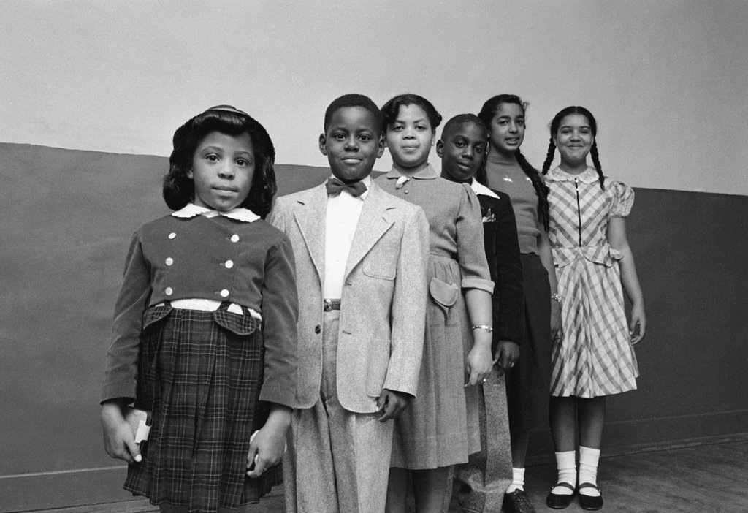

[*Linda Brown is third from the left*]

**Background**

U.S. Supreme Court, 1896 *Plessy v Ferguson*: Separate but Equal ruling (state segregation legal].

U.S. Supreme Court 1954 *Brown v. Board of Education*: 5 suits bundled into one, from parents in Kansas (Brown), Delaware, Virginia, South Carolina and Washington, D.C.

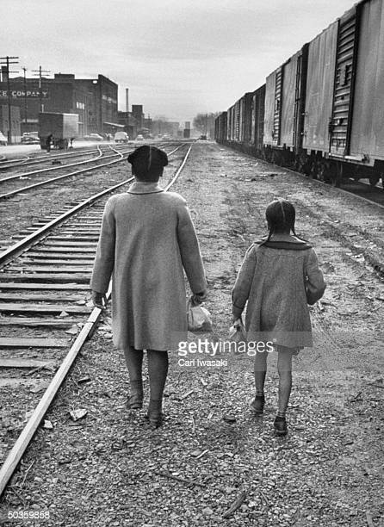

[Linda Brown and her sister walking to school]

*“I was a very young child when I started walking to school. I remember the walk as being very long at that time. In fact, it was several blocks up through railroad yards, and crossing a busy avenue, and standing on the corner, and waiting for the school bus to carry me two miles across town to an all black school. Being a young child, when I first started the walk it was very frightening to me um, and then when wintertime came, it was a very cold walk. I remember that. I remember walking, tears freezing up on my face, because I began to cry because it was so cold, and many times I had to turn around and run back home.”* **Linda Brown** [1985 interview for [“Eyes on the Prize: America’s Civil Rights Years](http://digital.wustl.edu/e/eop/eopweb/smi0015.0647.098lindabrownsmith.html" \t "_blank)”

**Below** are student and teacher resources that may be accessed online by copying the link and pasting into a browser. *Teachers are encouraged to preview all sources* and to add other books and articles to the list.

**Resources:**

Excellent background for teachers and students on *Brown v Board of Education* and on Linda Brown [died in 2018].

<https://www.smithsonianmag.com/smart-news/linda-brown-center-brown-v-board-education-has-died-180968608/>

Linda Brown’s Story narrative from California curriculum materials [scroll down].

<https://www.cde.ca.gov/ci/hs/im/brownvboard78.asp>

Map and picture that illustrate how close Linda lived to a white school but had to go a long way to her own.[Handout for students]

<http://www.littlejohnexplorers.com/jeff/brown/lindastoryr1.pdf>

YouTube video from archive photos of Linda Brown and *Brown v Board of Education* decision

<https://www.youtube.com/watch?v=g41X6_XY1rQ>

Short YouTube video on Linda Brown [under 3 minutes]

<https://untoldhistory.org/linda-carol-brown-brown-vs-board-of-education/>

Summary of Brown v. School Board ruling:

<https://kinginstitute.stanford.edu/encyclopedia/brown-et-al-v-board-education-topeka-kansas-et-al-347-us-483-349-us-294>

**For question #2:** Dr. Kenneth Clark’s “Doll Test” that showed the personal effects of segregated schools on black children [one of the arguments used by the NAACP lawyers]

**For question #3**: The Ruby Bridges story 6 years later in New Orleans, LA is an excellent example of how southern states resisted integration. ***Ruby Bridges Goes to School*** and ***I am Ruby Bridges***both are excellent and available in online video format.

Tony Morrison, *Remember: The Journey to School Integration*, 2004. The book features archive photos with fictionalized accounts of children who experienced school integration. Available in hardcover. Excellent classroom resource.

**Brief Chronology of Dr. Martin Luther King and the Civil Rights Movement**

***[1929****: [January 15] Martin Luther King, Jr. born in Atlanta, Georgia.]*

**1954:** US Supreme Court rules segregation in schools is unconstitutional *[Brown v Board of Education I]*

**1955**: *Brown v. Board of Education II*; [August] Emmett Louis Till murdered in Money, Mississippi.

[December] Rosa Parks refuses to give up her seat on the bus to a white man in Montgomery, Alabama. Montgomery Bus Boycott begins with Dr. Martin Luther King in a leadership role.

**1957**: [September] President Dwight Eisenhower sends federal troops to Central High School in Little Rock, Arkansas, to enforce school de-segregation and protect 9 black students.

**1960**: [November] Ruby Bridges is the first black child to de-segregate a whites-only elementary school in New Orleans, Louisiana; [February] Lunch counter Sit-ins begin in Greensboro, North Carolina.

**1961**: US Supreme Court ends segregation in all interstate bus service; in May 1961 “Freedom Riders” test southern state laws that separate whites and blacks on buses and in bus stations.

**1963:** Dr. King leads Birmingham Alabama campaign to desegregate downtown stores; [May 3] police attack children with dogs and fire hoses. [Aug 28] King delivers his “I Have a Dream” speech in Washington, DC; [September] 4 children killed in church bombing in Birmingham.

**1964**: Voter education drive in the South with *Freedom Summer.* [June] 3 civil rights workers killed by the Ku Klux Klan in Philadelphia, Mississippi; [July] President Lyndon Johnson signs the *Civil Rights Act of 1964*; [August] Mississippi Freedom Democratic Party and Fannie Lou Hamer attend the National Democratic Convention in Atlantic City, New Jersey; [Dec] Dr. King awarded the Nobel Peace Prize, Oslo, Norway.

**1965**: Dr. King takes voter rights campaign to Selma, Alabama; [March 25] thousands come to Selma for the March to Montgomery demanding voting rights for black citizens; [July] Congress passes the *Voting Rights Act of 1965*.

**1967**: [April 4] Dr. King publicly opposes the Vietnam War in his *Beyond Vietnam* speech and announces a Poor People’s Campaign to end poverty.

***[1968****: [April 4] Dr. King assassinated while leading a protest in support of sanitation workers on strike in Memphis, Tennessee. He was 39 years old.]*